Clarion University of Pennsylvania

**Calibration Services Incorporated**

CIS 411

Collin Switzer

Prince Brooks

Jacob Rice

Austin Barger

1. **About The Company**

Client: Calibration Services Incorporated

Contact: Jameen Stump VP/CFO

Calibration Services Inc. is a firm that specializes in onsite and in-house machine calibration and servicing of mechanical testing devices. Accredited by the ANAB, C.S.I has been serving customers for over forty years in eleven states and various US territories and services in excess of one-thousand machines per year.

1. **Problem**

CSI currently uses an outdated MS Works database, a system that was launched by Microsoft in 1991 and released its final version in 2007. The MS Works database also contains many empty, redundant, and nonsensical records that desperately needed updated, reformatted and/or removed. CSI also currently uses multiple physical mediums to track work progress, most notably the Bulletin Board. The Bulletin Board is posted on the wall in the main office and progress is manually marked with a bingo dauber. The client noted that an updated system was needed as the company is soon to be changing ownership to a new generation.

1. **Division of Labor**

Collin - Main Database View / Script

Prince - Bulletin Board / Script / Client Contact

Jake - Weekly Schedule / Work Order

Austin - Security and Work Orders / Wireframe

1. **Design**

Upon our initial gathering of information and analysis, we decide we work with multiple technologies. For the database we decided we would host it on a mySQL database and use PHP, HTML, CSS, and Javascript to create a web version that could be accessible from anywhere given the correct credentials. We wanted three main functions to be performed with the site. A main database view to perform CRUD operations on the database records, a bulletin board to mark progress so we can get rid of the need for a large physical one, and the generation of Solicitation Letters that let a customer know they need serviced.

USER MANUAL

CALIBRATION SERVICES INC.

Prince Brooks

Collin Switzer

Jake Rice

Austin Barger

1. Login Page
2. Main Page
3. Bulletin Board
4. Weekly Schedule
5. Work Order

**I. Login**

Purpose: Allow access to the website through a login.

1. Type in your username in the username text box
2. Type in your password in the password text box
3. Click login

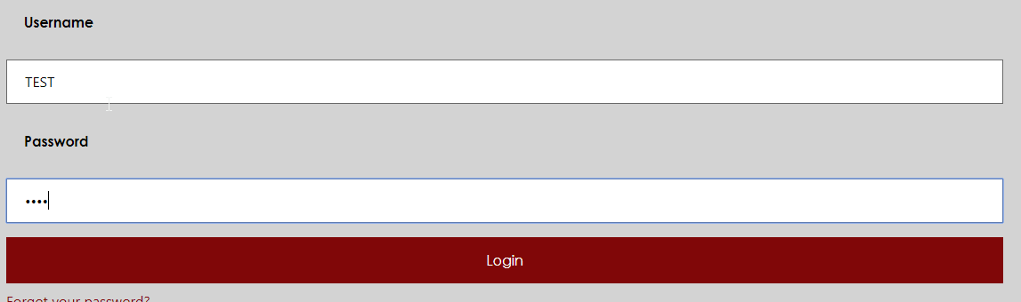

**II. Main Page**

Purpose: Allow the admin to manage the customer database

1. You can toggle between Simple and Advanced views with the checkbox underneath the nav
2. The search bar function is on the right side of the table and applies to all data shown (Department, Directions, etc)



1. Each entry has a delete and edit function on the right side of its table in either view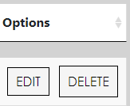
2. The subtables containing customer information dealing with Job Sites, Contacts, and Machinery can be shown by clicking on their respective buttons for each customer in their table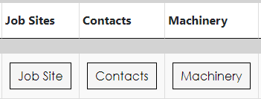
3. Adding Customers can be done by click the Add New Customer Button at the top of the page

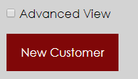

1. Anything in green in either the edit or new customer form MUST have information before it will be allowed to submit

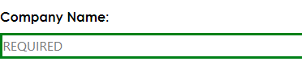

**III. Bulletin Board**

Purpose: The Bulletin Board page is where all companies are displayed by month and progress can be tracked and updated as tasks are performed.

1. To navigate to the bulletin board display view click ‘Bulletin Board’ on the navigation bar.
2. The page displayed shows all company progress for the current month on its initial load.
3. In the upper right hand corner of the page there is a dropdown box that indicates the current month that we are in. This dropdown box will always tell you the current month NOT the month that has been selected. The indicator in step 6 will tell you the month that you are viewing.
4. Click the black arrow on the dropdown box to see a list of all months in a year.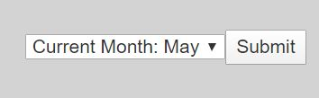
5. Select a month and click the submit button.
6. The Bulletin Board will now display the month you selected. This is indicated in the top left of the page. The indicator will always indicate the month that you are viewing.

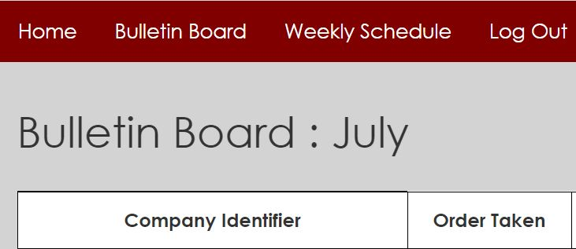

1. To update the progress of a company, navigate to any of the ‘Update Progress’ buttons that are displayed in the far right ‘Update Progress‘ column of the Bulletin Board.

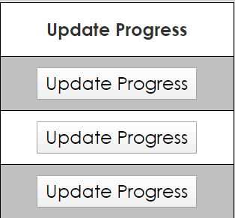

1. After clicking one of the update progress buttons, you will be taken to the Edit bulletin page. Here is where you will be able to mark progress as complete or incomplete.
2. **IMPORTANT:** If wanting to update progress in a month other than the current month, be sure to select the month you would like to edit once on the edit page. On the page’s load the current month is always displayed.
3. You will know you are on the edit bulletin page when all rows are changed into dropdown boxes that say ‘Select an Option’.

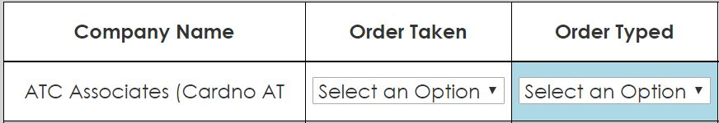

1. Click on the corresponding dropdown box for the process you want to mark as complete or incomplete. Be sure to mark all columns as complete or incomplete to post selections to the database.

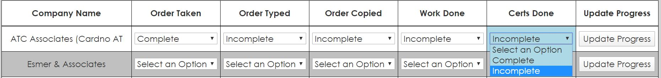

1. When all processes are marked, click the ‘Update Progress’ button that corresponds with the record you want to update.
2. You will now be taken to the Update Success Page.
3. The Update Success Page indicates that your record has been successfully updated. It will display the company identifier along with all of the values you marked as complete or incomplete.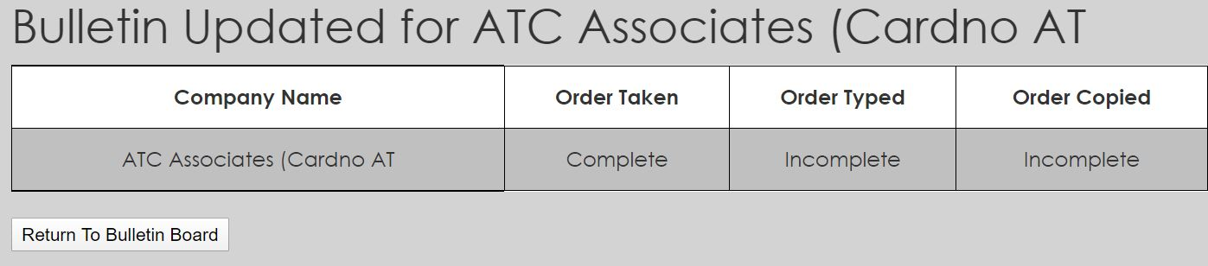
4. To return to the display bulletin page click the ‘Return to Bulletin Board’ button on the bottom left of the page.
5. You can now see the changes you made reflected in the display bulletin page!

**IV. Weekly Schedule**

Purpose: The purpose of the weekly schedule is to display the schedule for each tech for the current week (by default) or a specified week.

1. To navigate to the weekly schedule display view click ‘Weekly Schedule’ on the navigation bar.
2. Upon getting to the page, the schedule for all techs for the current week will be displayed.
3. If the current week’s schedule for a **specific technician** is desired, enter the tech’s initials (ex.: DLP) and click the update button.

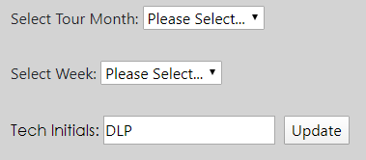

The schedule for that technician for the current week will be displayed below.

1. If a schedule for a **different week** is desired first select the month in the first dropdown.

Then, the weeks of that month will be displayed in the second dropdown, represented by the Monday of each week. 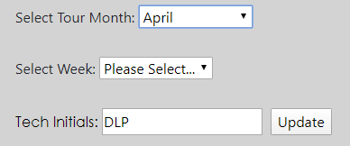

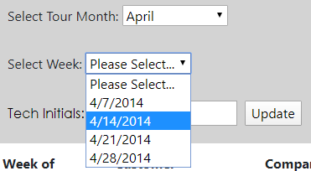

1. Select the desired week of the selected month and the schedule will be automatically updated to display the technician’s schedule on the specified week.



**V. Work Order**

1. The Work Order feature is currently still under development as of Monday, May 4, 2020. This feature will be added to the site in the near future to complete the functionality of it as a standalone solution for Calibration Services, Inc. to be able to edit its database easily and effectively moving into the future.